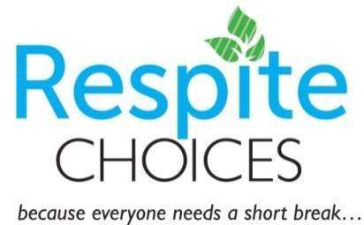

After School Respite Program

2907 Weston Road (Weston Rd & 401)

Program Begins September 3, 2019 to December 20, 2019

- Youth 11 - 17 with ASD
- 3 - 6 pm
- Program runs Monday to Friday. The program does not run during school closures
- 3 staff: 5 kids ratio
- Cost – $10/day (Families may have up to 3 days per week if available)
- Snack provided
- Activities include: help with homework, colouring, themed crafts, puzzles, board games, DVD movies, Wii, iPad games, Sensory room, outdoor activities.
- Program is run using the core principles of Applied Behavioural Analysis (ABA) with a focus on Preference Based Teaching (PBT)
For more information or to apply, contact:
Adrineh Bennett, Respite Coordinator
abennett@cltoronto.ca or 647.729.0450

*Please Note: if your child requires medication while at the program, Community Living Toronto requires a medical form to be completed prior to registration.

* It is the responsibility of the parent to arrange transportation with the school, most school boards require 2 - 3 weeks notice to change the route.

https://ca.apm.activecommunities.com/mycommunityhub/Activity_Search/after-school-respite-program/5345

Search After School Respite Program or #9428
Text only version is available if needed.

